**Lesson 04 Demo 01**

**Setting up a Grafana Instance**

**Objective:** To demonstrate the process of installing Grafana, starting the server, and configuring it for monitoring and visualizing system metrics through a dashboard

**Tools required:** Linux operating system

**Prerequisites:** Basic understanding of Linux shell and commands

Steps to be followed:

1. Install Grafana from the APT repository
2. Start the Grafana server
3. Access the Grafana UI

**Step 1: Install Grafana from the APT repository**

1. Open the terminal on the system and install the prerequisite packages for Grafana using the following command:

**sudo apt-get install -y apt-transport-https software-properties-common wget**

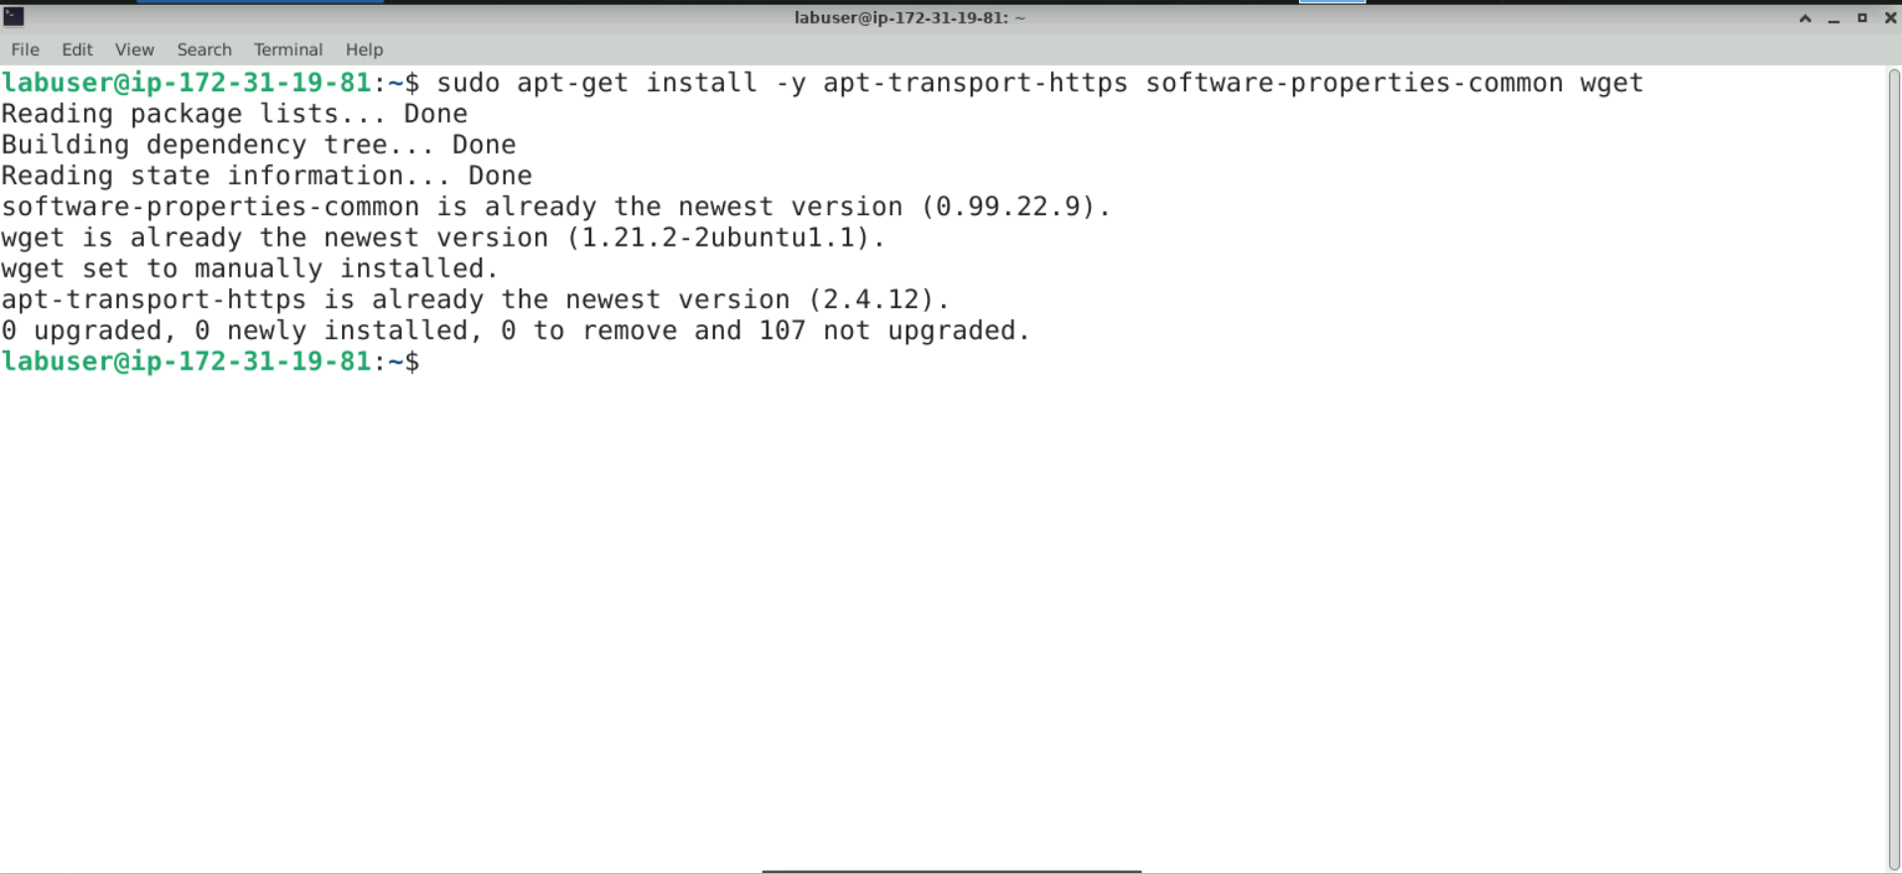

**Note:** These steps describe installing Grafana from the **APT repository**. Grafana can also be installed by downloading a .**deb** package or a binary**.tar.gz** file.

1. Execute the following commands to create a directory for keyrings and import Grafana's GPG key:

**sudo mkdir -p /etc/apt/keyrings/**

**wget -q -O - https://apt.grafana.com/gpg.key | gpg --dearmor | sudo tee /etc/apt/keyrings/grafana.gpg > /dev/null**

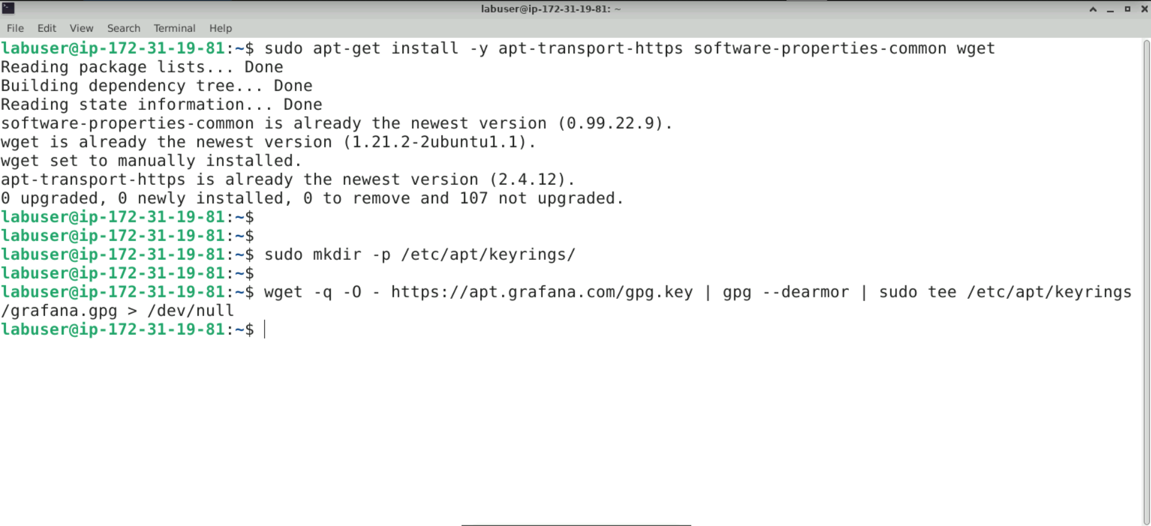

1. Execute the following command to add a stable Grafana repository to the system's APT sources list:

**echo "deb [signed-by=/etc/apt/keyrings/grafana.gpg] https://apt.grafana.com stable main" | sudo tee -a /etc/apt/sources.list.d/grafana.list**

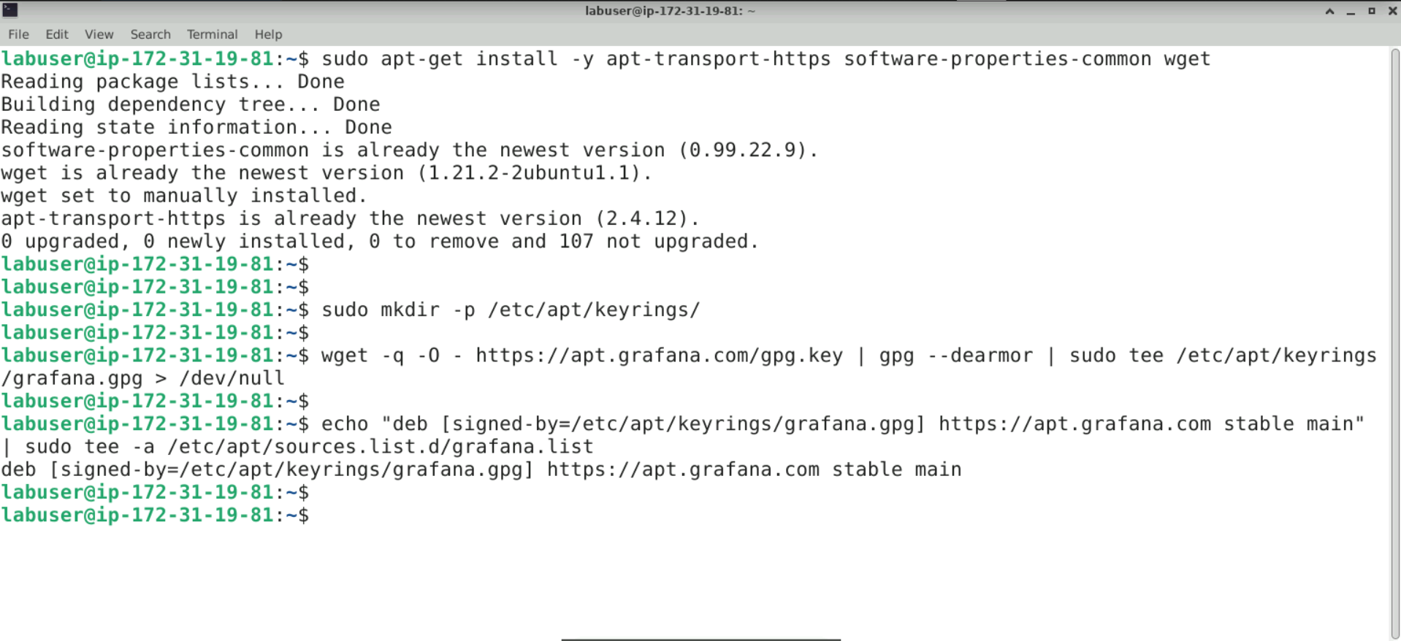

1. Execute the following command to add Grafana's beta repository to the APT sources list:

**echo "deb [signed-by=/etc/apt/keyrings/grafana.gpg] https://apt.grafana.com beta main" | sudo tee -a /etc/apt/sources.list.d/grafana.list**

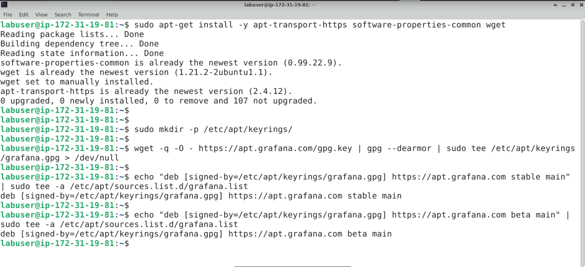

1. Run the following command to update the package list to include the Grafana repositories:

**sudo apt-get update**

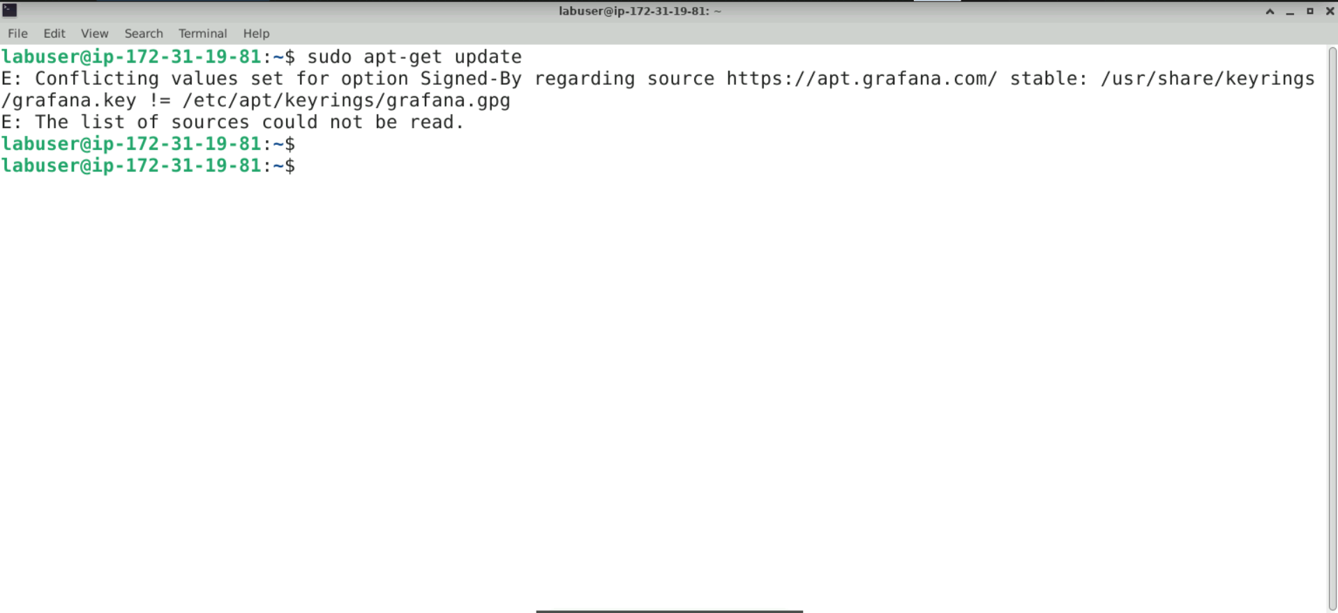

**Note:** A conflict error may occur during the update after adding the repository.

1. Run the following commands to remove the Grafana keyring file and open the grafana.list file in the **Vim** editor to resolve the conflicting issues:

**sudo rm /usr/share/keyrings/grafana.key**

**sudo vim /etc/apt/sources.list.d/grafana.list**

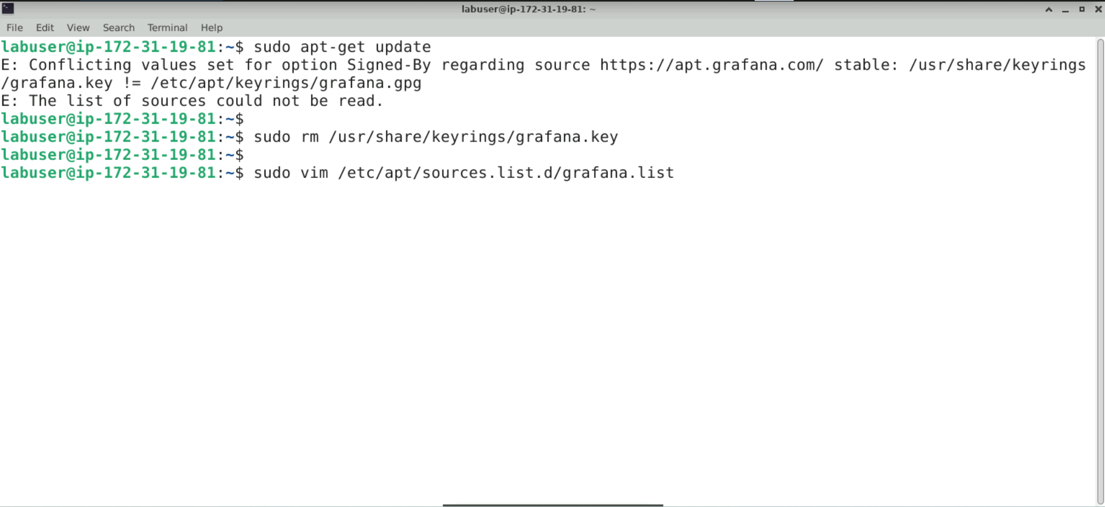

1. Remove the first line containing **grafana.key**; keep the remaining lines that include **grafana.gpg**, then save and exit the file

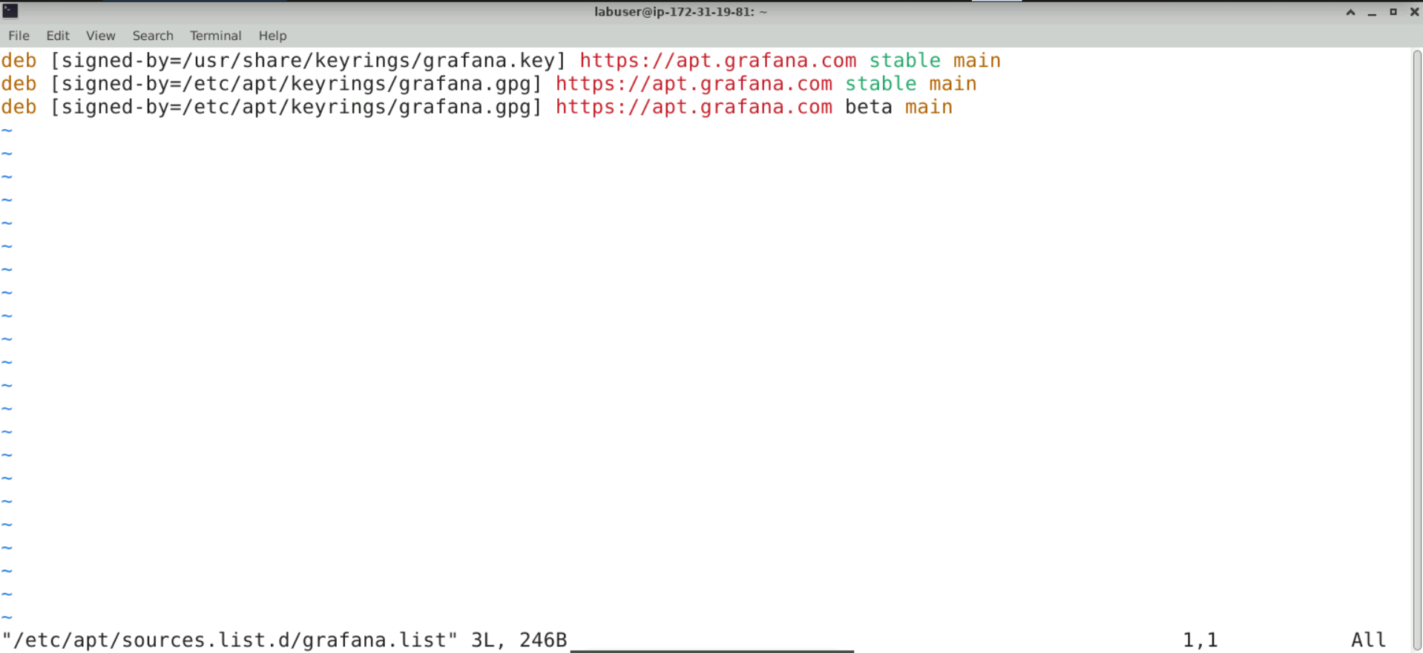

The **grafana.list** file should look like this:

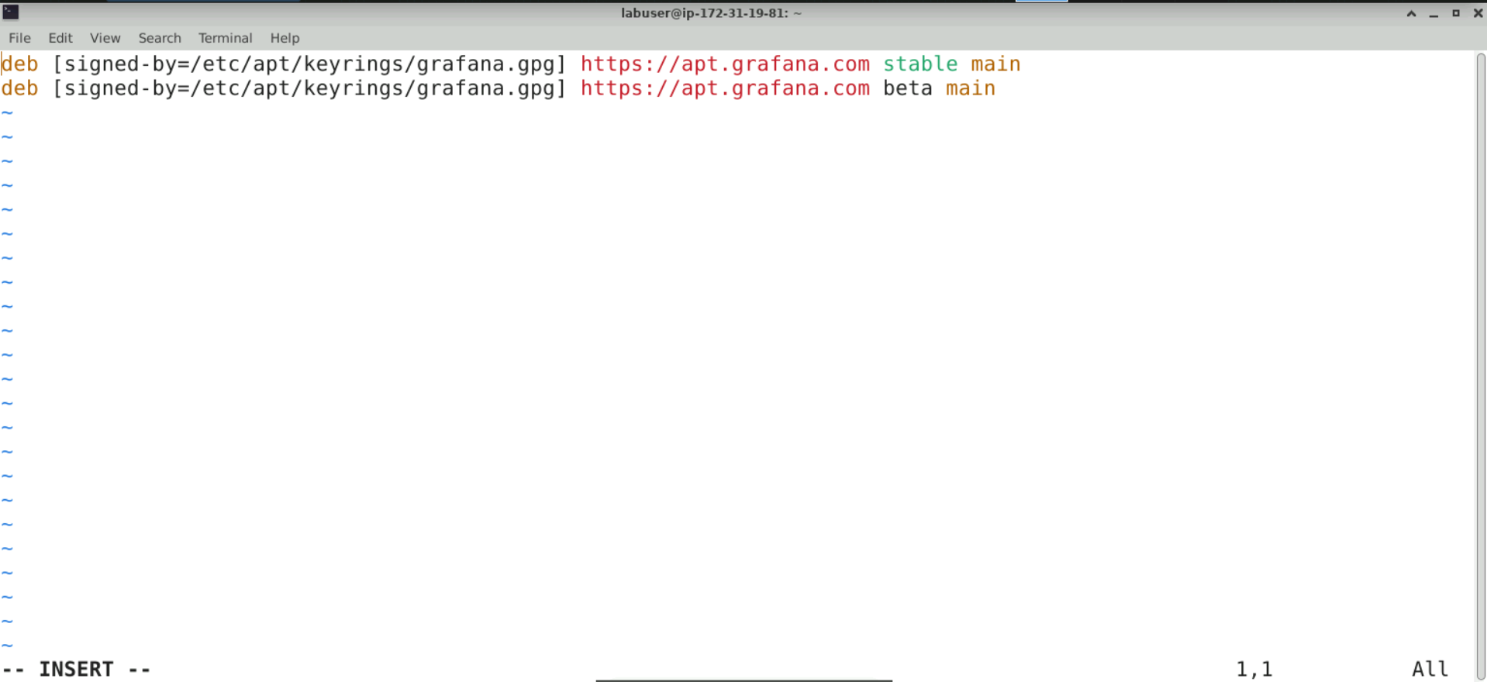

1. Execute the following command to update the package list once the grafana.list file  
   is updated:

**sudo apt-get update**

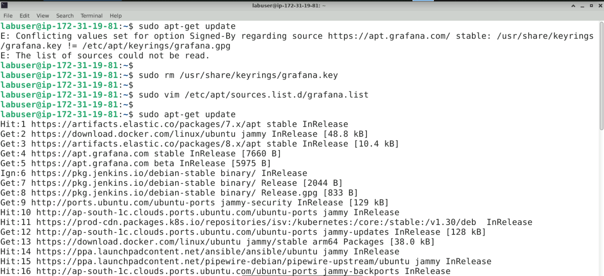

1. Using the following command, install the Grafana open-source edition from the repository:

**sudo apt-get install grafana**

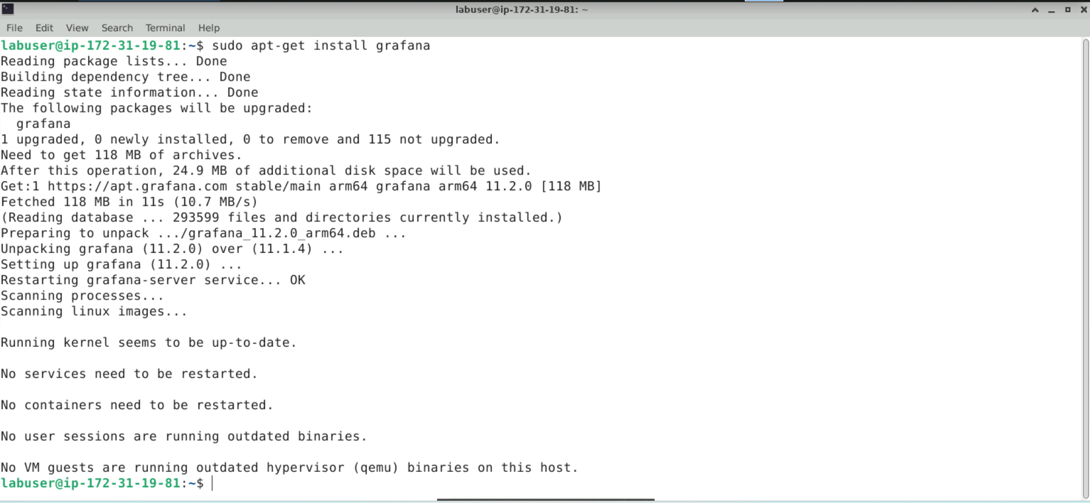

**Step 2: Start the Grafana server**

1. Execute the following commands to reload the system manager configuration, start the Grafana server, and check its status:

**sudo systemctl daemon-reload**

**sudo systemctl start grafana-server**

**sudo systemctl status grafana-server**

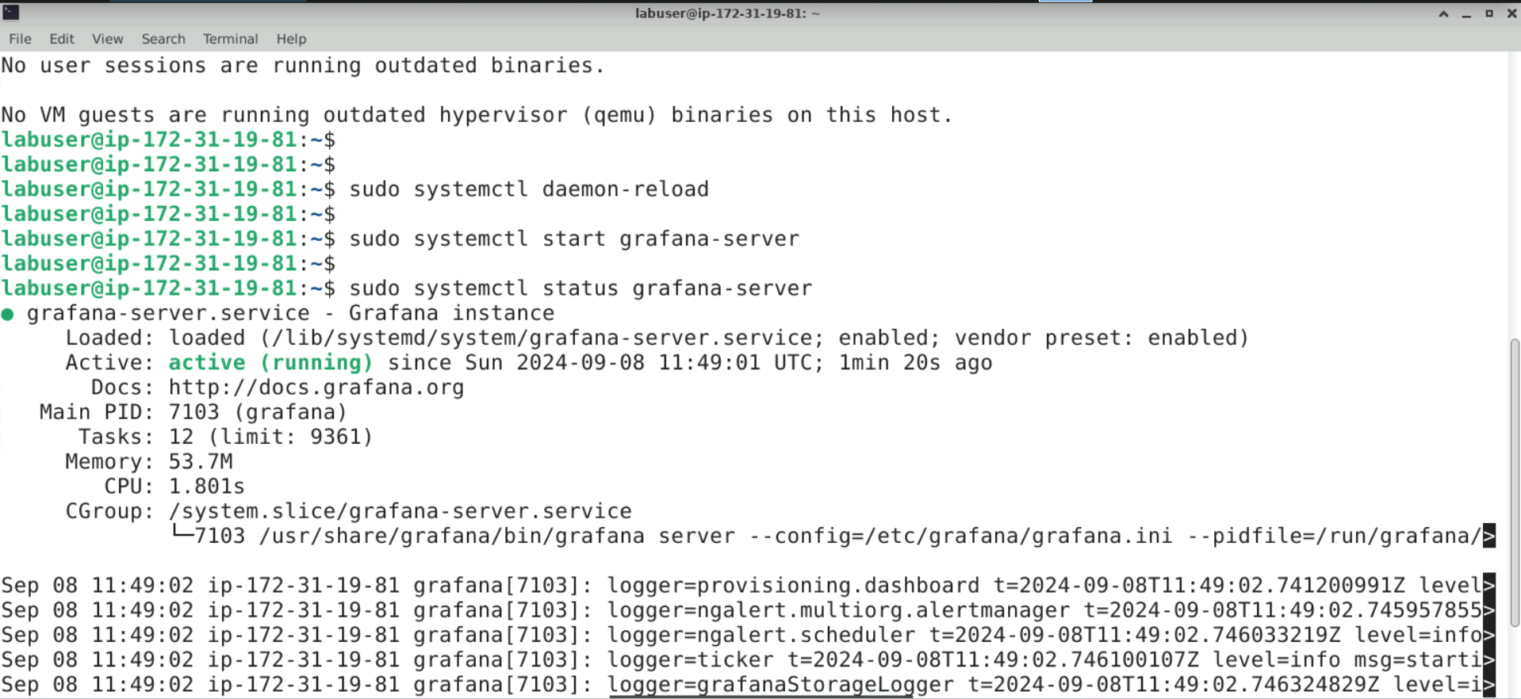

**Note**: Press **Ctrl+C** to exit the status check

**Step 3: Access the Grafana UI**

1. Open your preferred browser and enter the URL **http://localhost:3000**

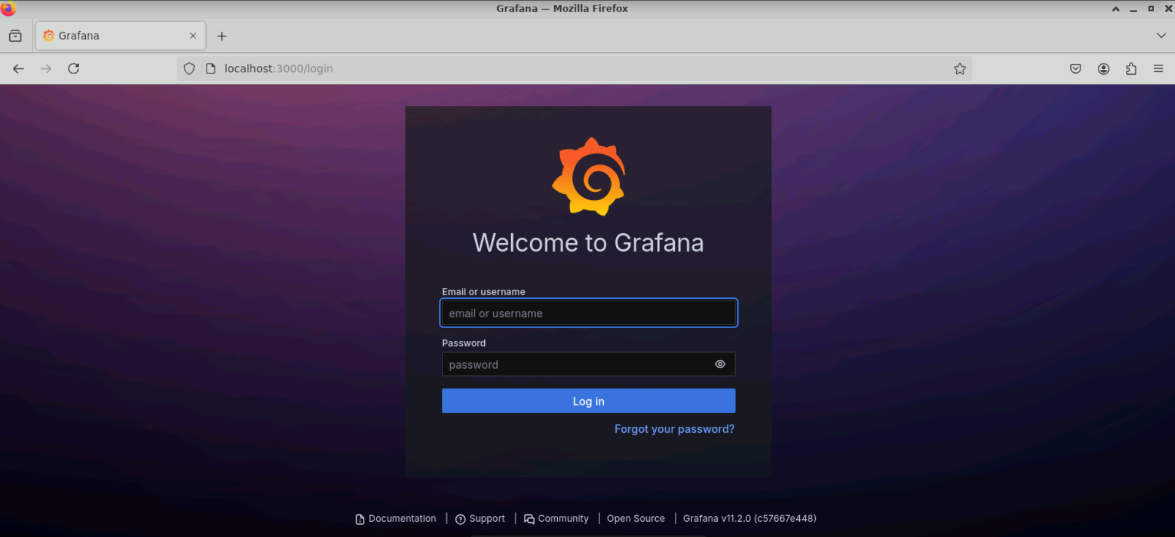

The Grafana UI will appear as shown above.

1. Enter **admin** as both the **Username** and **Password**, then click **Log in**

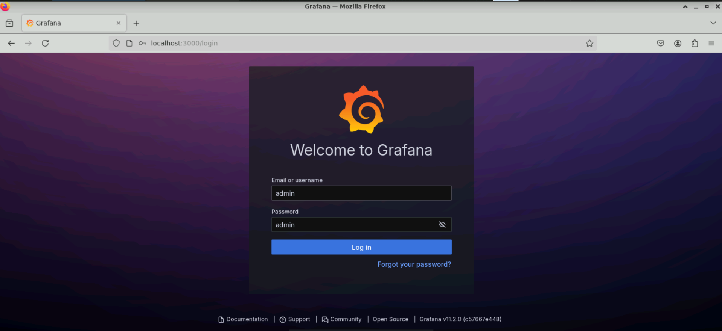

1. Once the login is successful, a prompt will appear to change the password. Change the password and submit it, or skip this step to continue using the default password

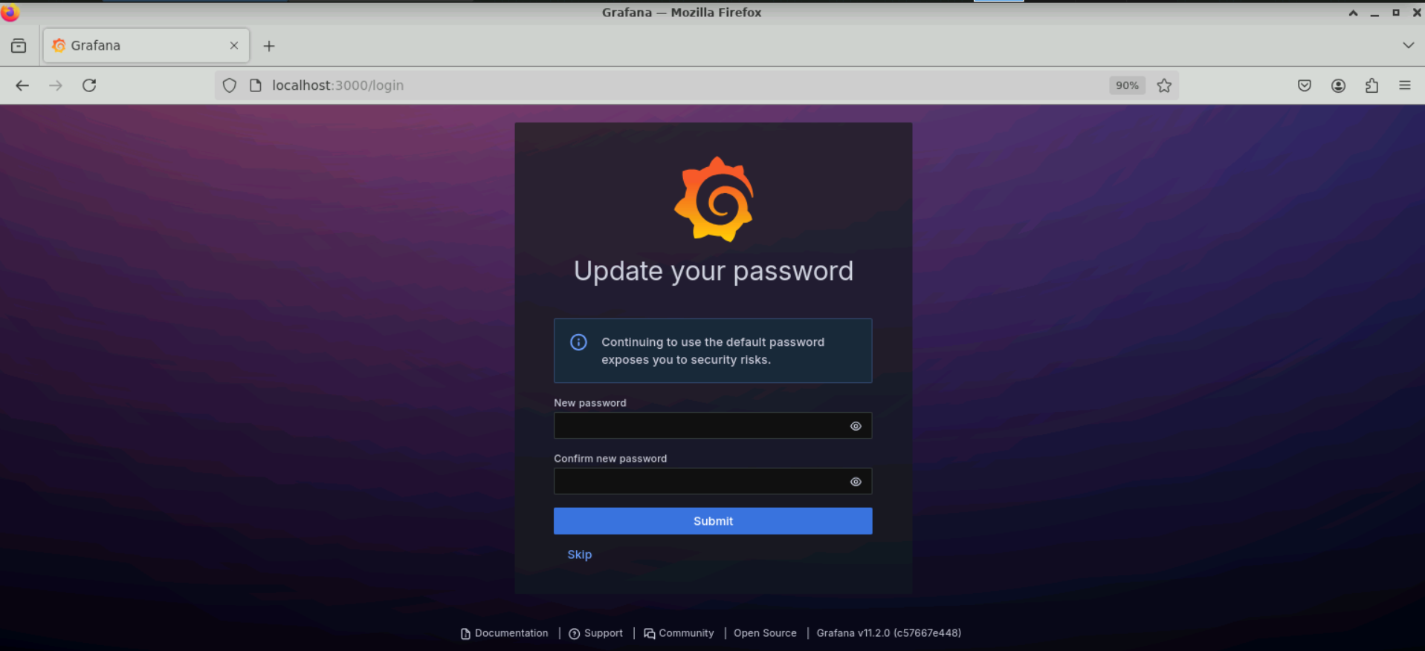

The Grafana dashboard will appear as shown below:

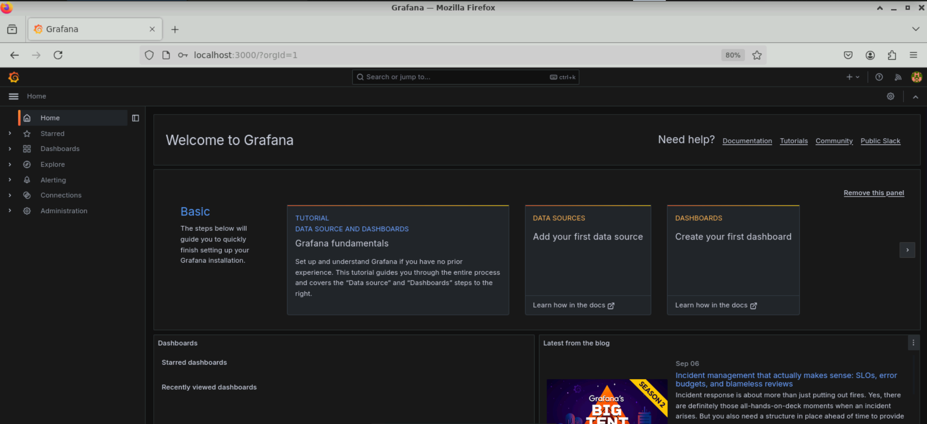

By following these steps, you have successfully installed Grafana from the APT repository, started the Grafana server, completed the initial setup, and accessed the Grafana dashboard to monitor and visualize system metrics.